NUMERICAL INTEGRARION

50. What do you mean by numerical integration? Discuss the principle of integration method.

Numerical integration is the approximate computation of an integral using numerical techniques1. It is also sometimes called quadrature1. Numerical integration involves a family of algorithms for calculating the numerical value of a definite integral

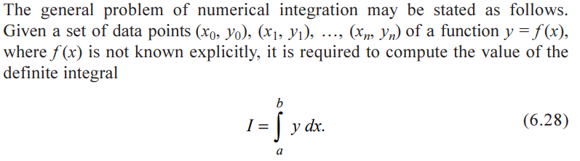

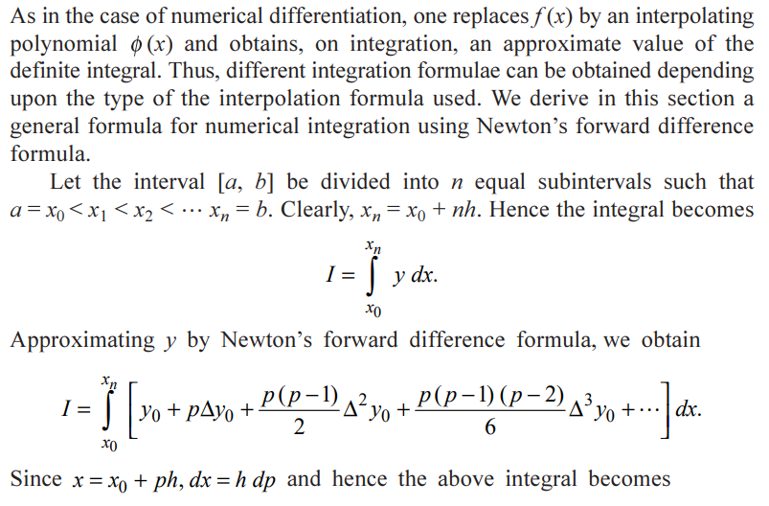

51.Write down the Newton-cote's formula for the equidistant ordinates.

Newton-Cotes formulas are a family of numerical integration methods used to approximate definite integrals. The Newton-Cotes formula for equidistant ordinates is often referred to as the "Trapezoidal Rule." It's a simple method that approximates the area under a curve by dividing the interval into equal subintervals and approximating the curve as a series of trapezoids.

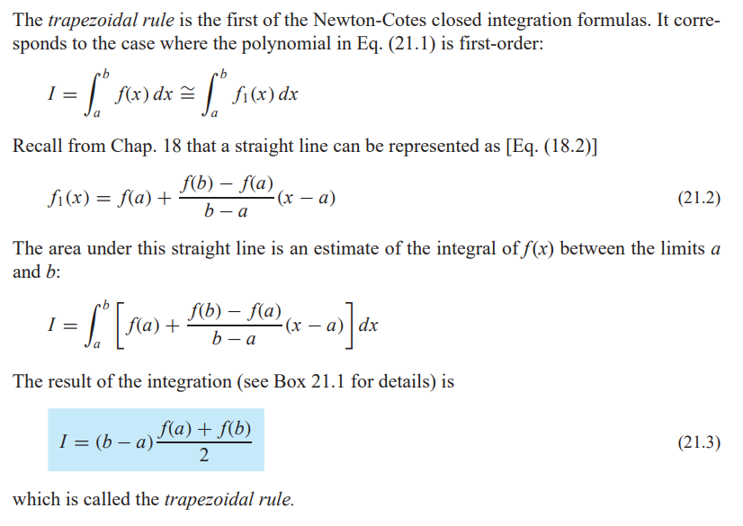

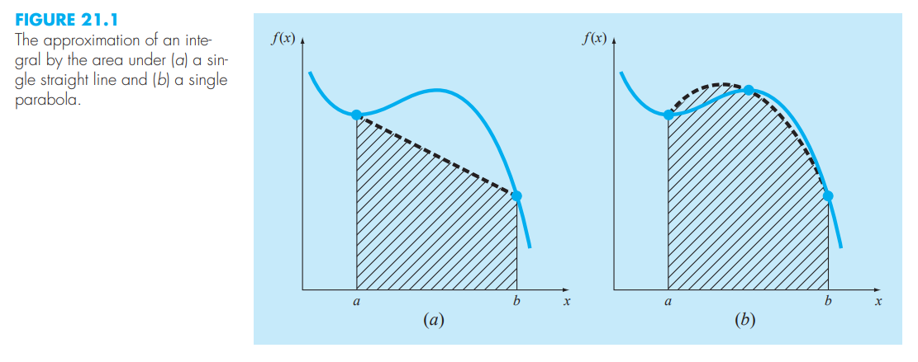

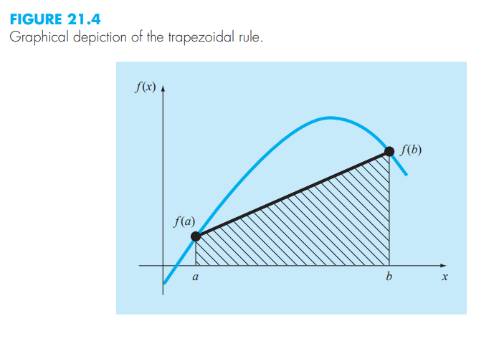

52. What is the local error term in Trapezoidal formula. Write the order of the errors of trapezoidal rule.

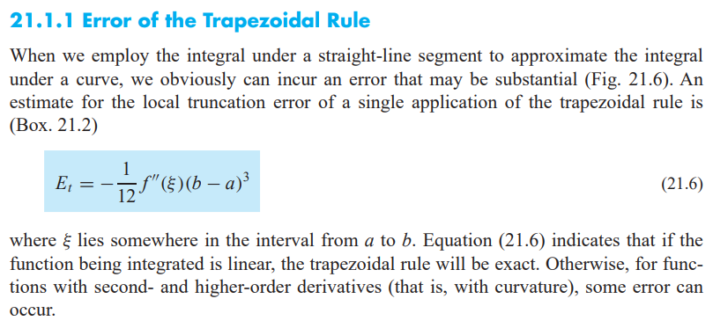

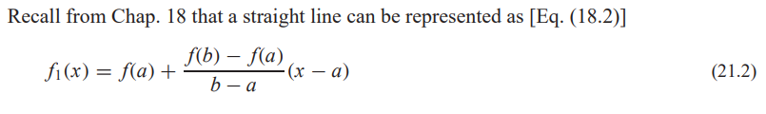

The order of the error in the Trapezoidal Rule is O(h2), where "h" is the width of the subintervals used in the approximation.

53 State the formula for trapezoidal rule of integration.

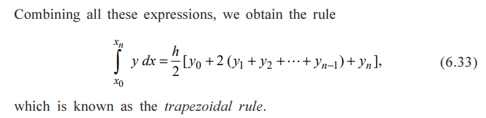

WHERE,,

X0 and Xn are the lower and upper limits of integration.

n is the number of subintervals.

h is the width of each subinterval, calculated as (X0 - Xn) / n.

y is the function being integrated.

54. When does Trapezoidal rule gives exact result.

in the case of linear function, the second forward differences is zero, hence, the Trapezoidal rule gives exact value of the integral if the integrand is a linear function.

Here is a simple graphical representation:

Consider the function f(x) = 2x + 3 over the interval [a, b]. This function is a straight line with a slope of 2, and it intersects the x-axis at x = -3/2.

1. If you use the Trapezoidal Rule to approximate the integral of this function over the interval [a, b], you'll get the exact result because the function is a straight line.
2. The Trapezoidal Rule divides the area under the curve into trapezoids. In this case, those trapezoids will exactly fit under the straight line, and the sum of the areas of these trapezoids will be the exact integral.

a b

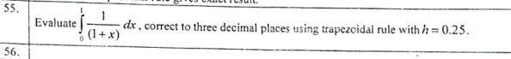

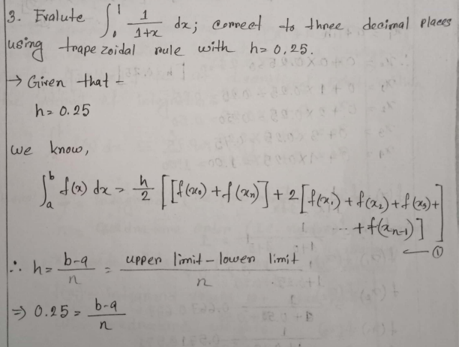

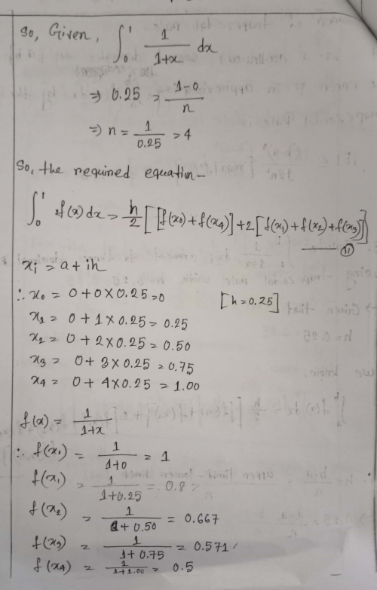

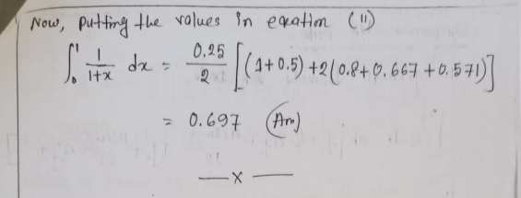56.

57.Write down the order of the errors of Simpson's one third rule.

The order of the error in Simpson's 1/3 Rule for numerical integration is O(h4),

where "h" is the width of the subintervals used in the approximation.

This means that the error decreases as the width of the subintervals is reduced to the fourth power.

Now…

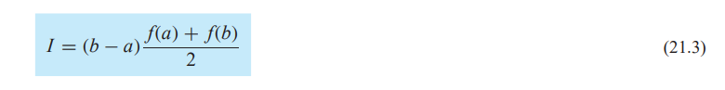

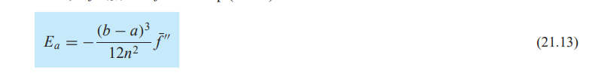

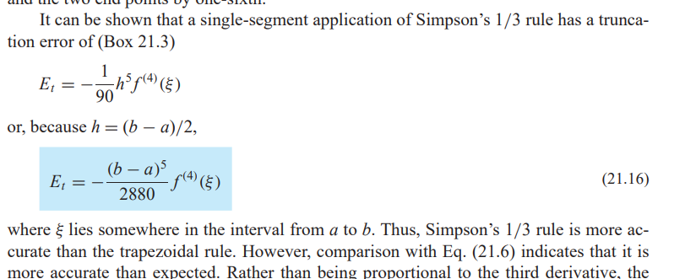

58.When do you apply Simpson's 1/3 rule? When does Simpson rule gives exact result? How Simpson's 1/3 rule differs from Trapezoidal rule? Drive the formula for Simson's 1/3 rule.

Simpson's 1/3 Rule is applied to approximate the definite integral of a function over an interval [a, b] when the following conditions are met:

1. The interval [a, b] is divided into an even number of subintervals.
2. The function is reasonably smooth within these subintervals, meaning it does not exhibit abrupt changes or discontinuities.

if the function you are integrating is a quadratic (a polynomial of degree 2) or a linear function, Simpson's Rule will give you the exact result.

The reason for this is that Simpson's Rule approximates the function as a piecewise quadratic (Simpson's 1/3 Rule) or a piecewise cubic (Simpson's 3/8 Rule), and when the function being integrated is a quadratic or linear function, this approximation is exact.

For higher-degree polynomial functions, Simpson's Rule will provide an approximation, and the accuracy of the approximation depends on the number of subintervals used and the degree of the polynomial. To decrease the error for higher-degree polynomials, you can use more subintervals.

60.Write down the Simpson's 1/3-Rule in numerical integration.

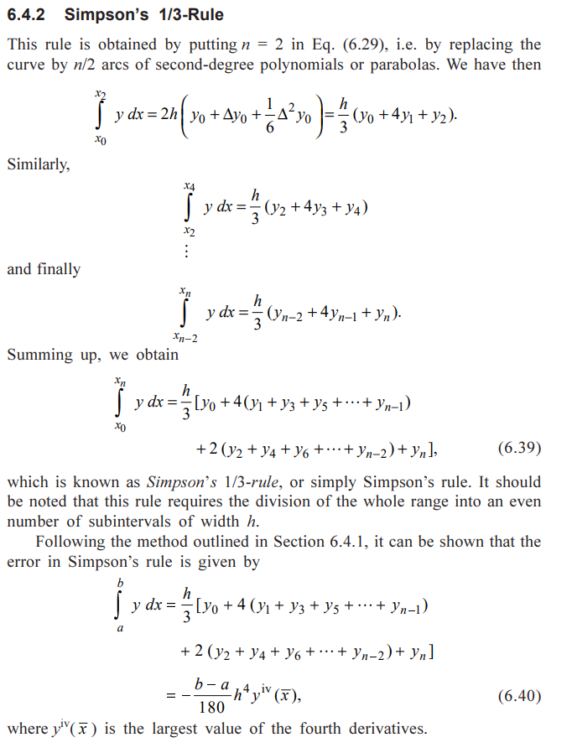

**Another anserr::::**

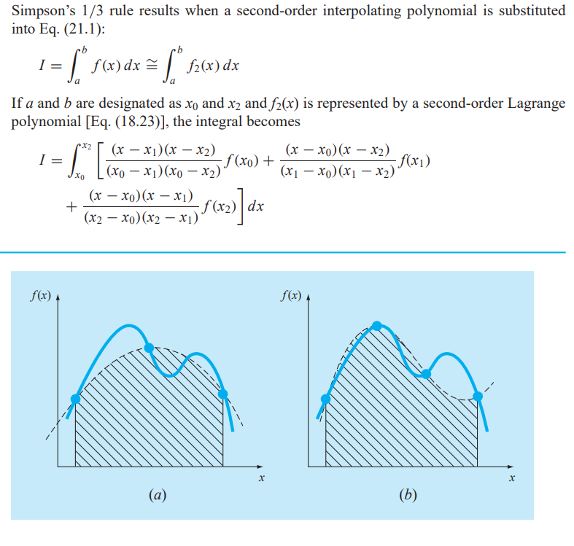

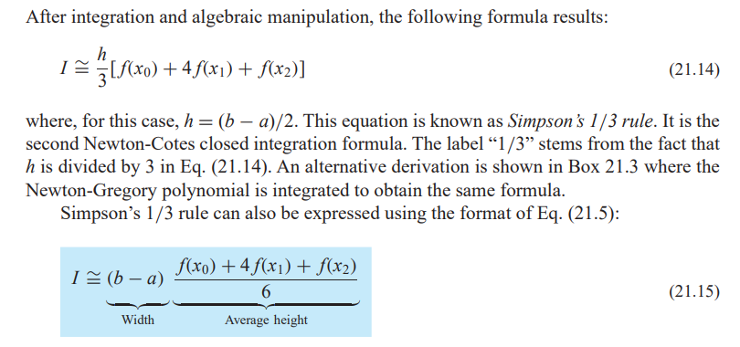

61.Compare trapezoidal rule and Simpson's one third rule.

|  |  |
| --- | --- |
| Trapezoidal Rule | Simpson's 1/3 Rule |
| Lower accuracy (O(h^2)) | Higher accuracy (O(h^4)) |
| Exact for linear (degree 1) | Exact for quadratic (degree 2) |
| Less accurate for higher degrees | More accurate for higher degrees |
| More evaluations | Fewer evaluations |
| Simpler | Slightly more complex |
| Quick, moderate accuracy | Higher accuracy, smoother curves |

62.State Simpson's three eight rule. On what type of intervals, simpson;s three-eight rule can be applied.

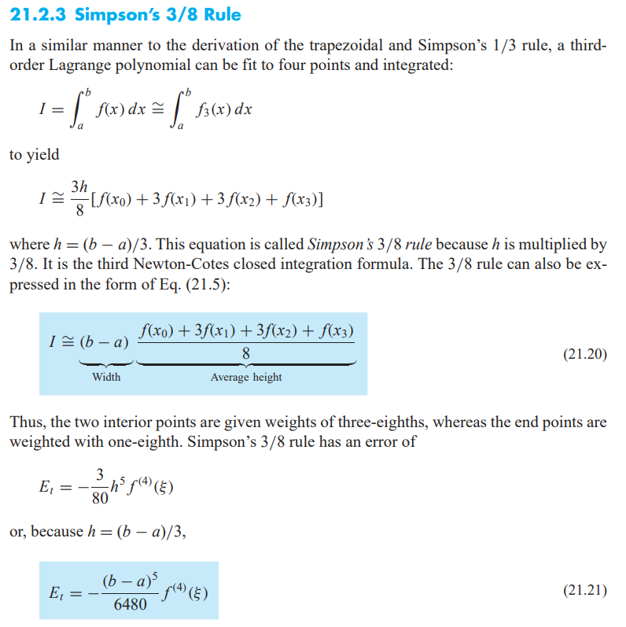

Simpson's 3/8 Rule is a numerical integration method that can be applied to integrate functions over intervals with evenly spaced subintervals. Specifically, it is designed for integration over intervals that are evenly divided into subintervals, where the total number of subintervals is a multiple of 3.

The rule is applied when the interval [a, b] is divided into n subintervals, where "n" is divisible by 3. Each subinterval has the same width, and Simpson's 3/8 Rule fits a cubic polynomial to each set of three consecutive subintervals. This means that the rule can be applied to intervals with a length that is evenly divisible by 3, such as [a, a+h], [a, a+2h], [a, a+3h], and so on.

For example, if you have an interval [a, b] and you want to use Simpson's 3/8 Rule, you could divide it into subintervals like [a, a+h], [a+h, a+2h], [a+2h, a+3h], and so forth, where "h" is (b - a)/n. This ensures that the total number of subintervals is a multiple of 3, as required by the rule.

63. Compare Simpson's 3/8 rule and Simpson's one third rule.

|  |  |
| --- | --- |
| Simpson's 3/8 Rule | Simpson's 1/3 Rule |
| Multiple of 3 subintervals | Multiple of 2 subintervals |
| Fits cubic polynomials | Fits quadratic polynomials |
| Exact for cubic (degree 3) | Exact for quadratic (degree 2) |
| High accuracy (O(h^4)) | High accuracy (O(h^4)) |
| More evaluations | Fewer evaluations |
| When number of subintervals not | Generally used when even number |
| divisible by 2, and higher | of subintervals and higher |
| accuracy is needed | accuracy is needed |

64.1 Evaluate f-dx by Simpson's rule with 4 strips. Determine the error by direct integration.

65.

Evaluate the integral

J(5+2 sin.x) dx

i) Analytically

ii) Multiple application of Simpson's rule with n = 4.